Terraform Task-2

Step1:

Creating Ec2 instance in Two different region and installed ngnix in two Ec2 Also

Screenshot mentioned Below

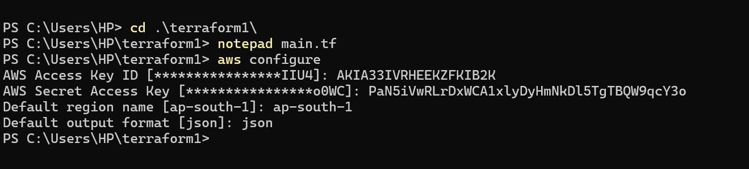

Main.tf mentioned below

https://github.com/karthicmariappan/demo/blob/main/main.tf

Terraform init command used

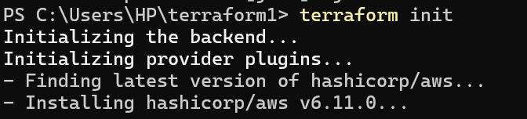

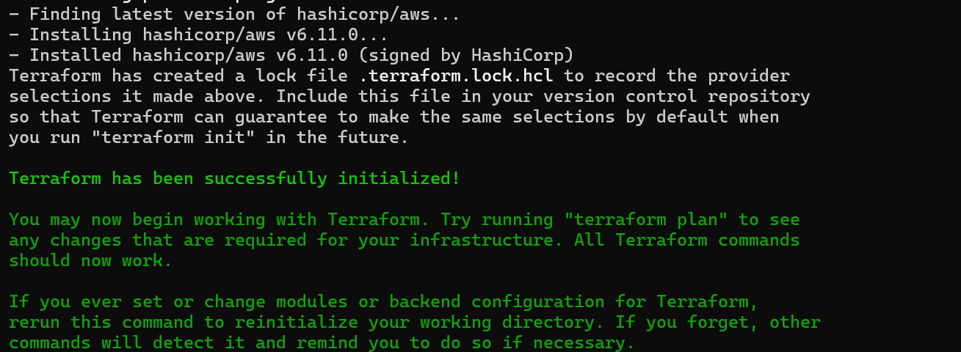

Terraform validate

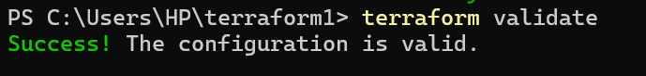

Terraform plan

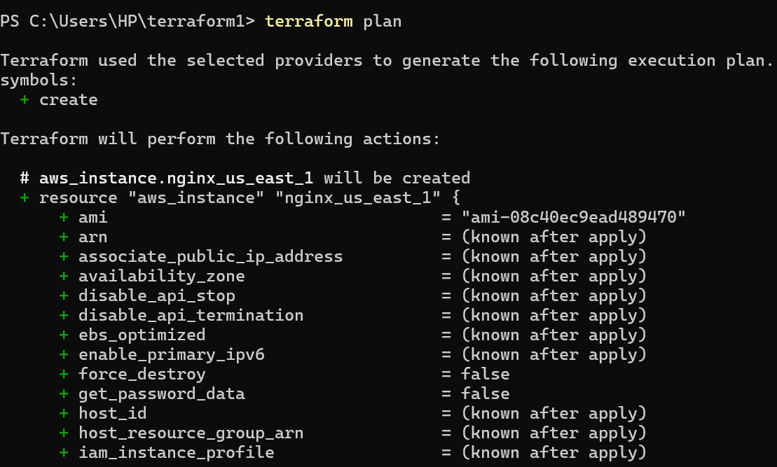

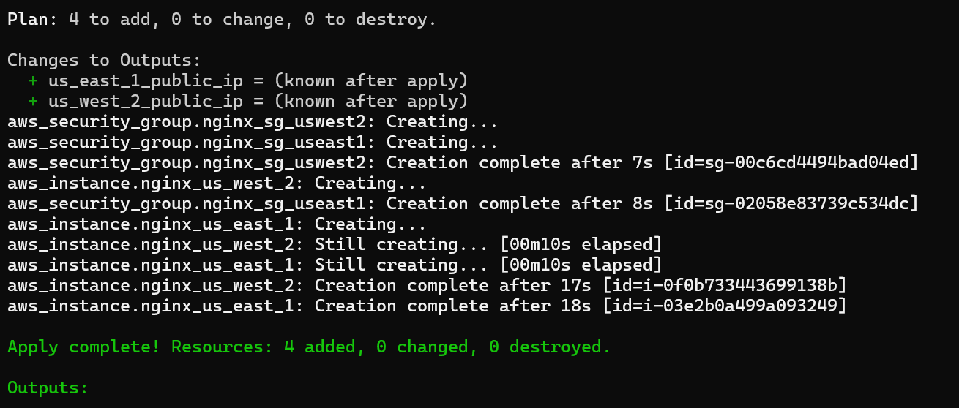

Teraform apply

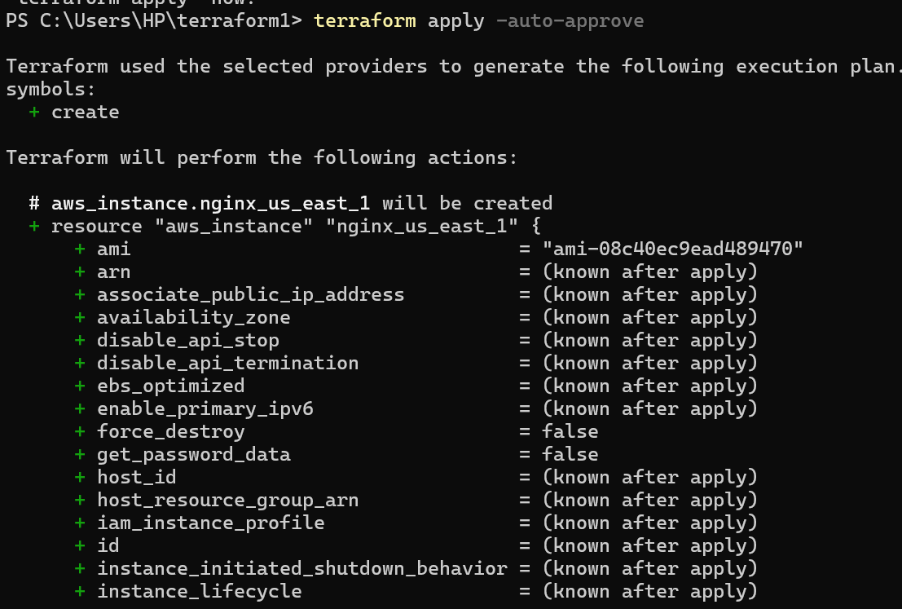

Confirm the Ec2 in boht the region

